**Project Planning Phase**

**Project Planning Template (Product Backlog, Sprint Planning, Stories, Story points)**

|  |  |
| --- | --- |
| **Date** | **12/03/2025** |
| **Team ID** | **SWTID1744456946** |
| **Project Name** | **MediBoard** |
| **Maximum Marks** | **5 Marks** |

**Product Backlog, Sprint Schedule, and Estimation**

|  |  |  |  |  |  |  |
| --- | --- | --- | --- | --- | --- | --- |
| **Sprint** | **Functional Requirement**  **(Epic)** | **User Story**  **Number** | **User Story / Task** | **Story Points** | **Priority** | **Team Members** |
| Sprint-1 | User Registration | USN-1 | As a user, I can register by entering email, password, and confirming password. | 2 | High | Shams Shadan Khan |
| Sprint-1 | Email Verification | USN-2 | As a user, I will receive a confirmation email after  registration. | 1 | High | Aamir Khan |
| Sprint-2 | Social Login (Facebook) | USN-3 | As a user, I can register through  Facebook. | 2 | Low | Aamir khan |
| Sprint-1 | Social Login (Gmail) | USN-4 | As a user, I can register through  Gmail. | 2 | Medium | Mohd Ameen Hussain |
| Sprint-1 | Login | USN-5 | As a user, I can log into the application with email and  password. | 1 | High | Shams Shadan Khan |
| Sprint-2 | Doctor Listing | USN-6 | As a user, I can view available doctors with  specialization. | 3 | High | Mohd Ameen Hussain |
| Sprint-2 | Booking System | USN-7 | As a user, I can book appointments  with a doctor. | 4 | High | Mohd Ameen Hussain |
| Sprint-3 | Booking Confirmation | USN-8 | As a user, I get a booking confirmation with doctor name and time. | 2 | Medium | Shams Shadan Khan |
| Sprint-3 | Profile Management | USN-9 | As a user, I can manage | 3 | Medium | Aamir Khan |

|  |  |  |  |  |  |  |
| --- | --- | --- | --- | --- | --- | --- |
|  |  |  | my profile details and  past bookings. |  |  |  |
| Sprint-4 | Admin Dashboard | USN-10 | As an admin, I can view/manage  doctors and appointments. | 5 | High | All Members |

**Project Tracker, Velocity & Burndown Chart**

|  |  |  |  |  |  |  |  |  |  |  |
| --- | --- | --- | --- | --- | --- | --- | --- | --- | --- | --- |
|  | **Sprint** | **Total Story Points** |  | **Duration** | **Sprint Start Date** | **Sprint End Date (Planned)** |  | **Story Points Completed (as on Planned End**  **Date)** | **Sprint Release Date**  **(Actual)** |  |
|  | Sprint-1 | 12 |  | 5 Days | 1 March 2025 | 05 March  2025 |  | 12 | 05 March  2025 |  |
|  | Sprint-2 | 12 |  | 3 Days | 6 March  2025 | 08 March  2025 |  | - | - |  |
|  | Sprint-3 | 9 |  | 3 Days | 9 March  2025 | 11 March  2025 |  | - | - |  |
|  | Sprint-4 | 3 |  | 3 Days | 12 March  2025 | 14 March  2025 |  | - | - |  |

**Team Member Roles and Responsibilities:**

**Mohd Ameen Hussain (Backend):**

* Primary responsibility for server-side development using Node.js and Express
* Database design and implementation with MongoDB
* API development and integration
* Backend security and authentication
* Payment gateway integration

**Shams Shadan Khan (Frontend):**

* User interface design and implementation using React.js
* Responsive web design and CSS styling
* Form validation and user experience
* Component design and implementation
* Review and rating system UI

**Aamir khan (Full Stack):**

* Cross-functional support for both frontend and backend tasks
* Authentication system implementation
* Integration testing between frontend and backend
* Appointment booking system development
* Payment system integration

**Task Distribution by Sprint:**

|  |  |  |  |  |  |
| --- | --- | --- | --- | --- | --- |
| **Team Member** | **Sprint 1 (Story**  **Points)** | **Sprint 2 (Story**  **Points)** | **Sprint 3 (Story**  **Points)** | **Sprint 4 (Story**  **Points)** | **Total Story Points** |
| Mohd Ameen Hussain | 4 | 4 | 5 | 0 | 13 |
| Shams Shadan Khan | 6 | 4 | 0 | 3 | 13 |
| Aamir khan | 2 | 4 | 4 | 0 | 10 |

**Velocity:**

Based on our planning:

* Sprint 1: 12 story points / 5 days = 2.4 story points per day
* Sprint 2: 12 story points / 3 days = 4 story points per day
* Sprint 3: 9 story points / 3 days = 3 story points per day
* Sprint 4: 3 story points / 3 days = 1 story point per day

**Burndown Chart**

* **X-Axis:** Sprint Days
* **Y-Axis:** Remaining Story Points
* **Lines:**
  + **Ideal Burndown Line:** Straight line from total points to 0 across the sprint days.
  + **Actual Work Line:** Updated daily to reflect real progress.

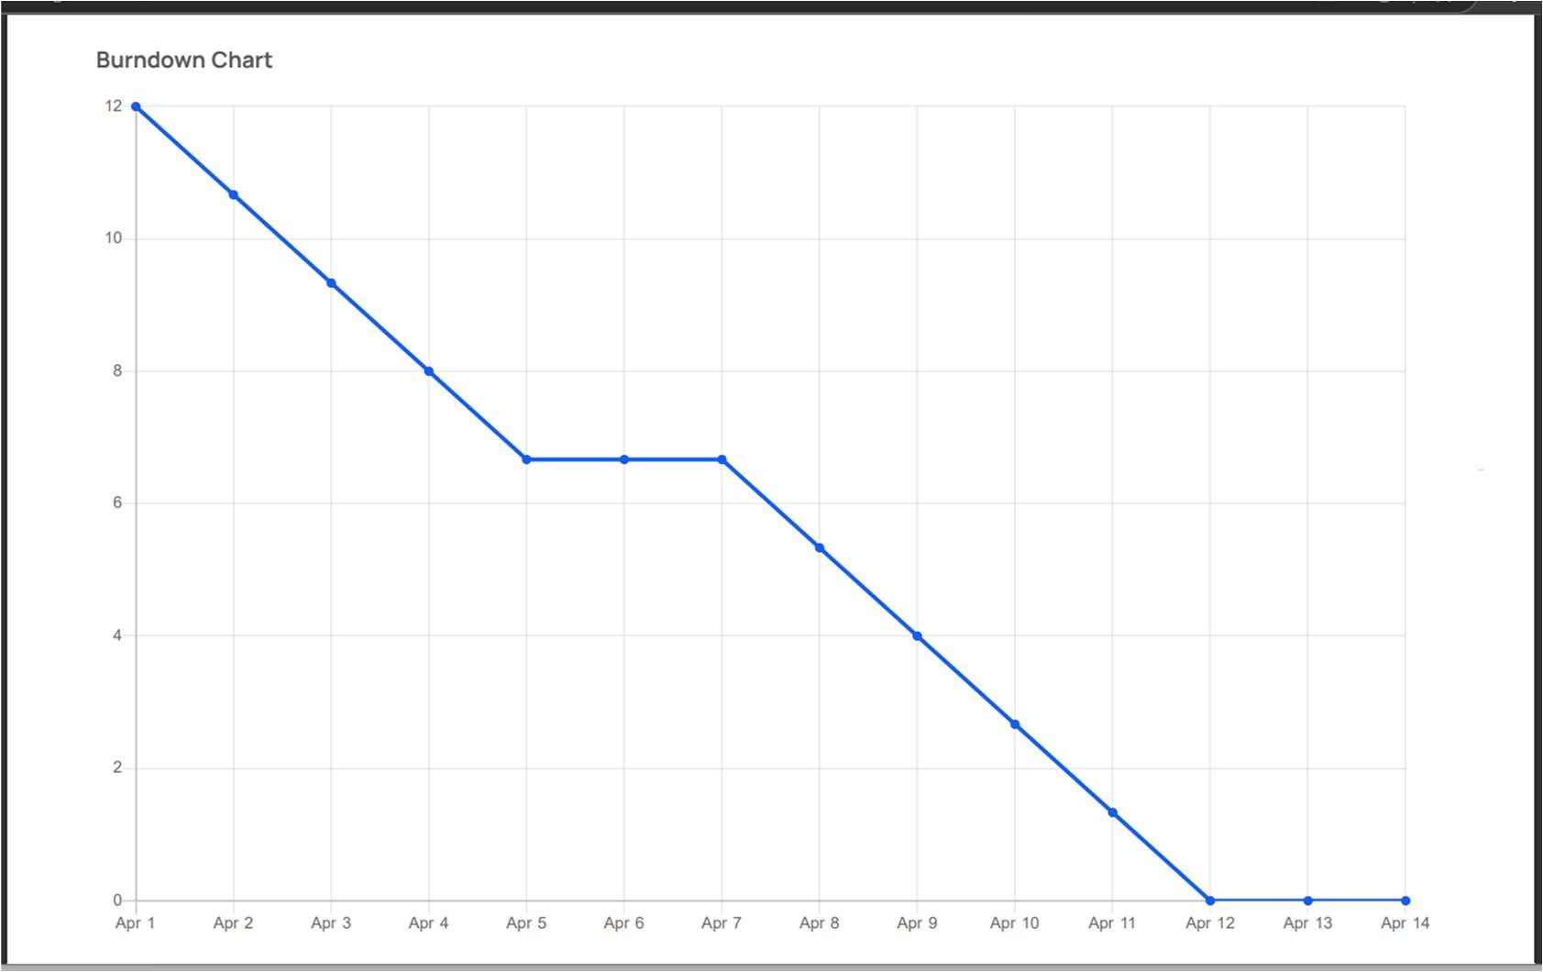

The burndown chart shows a healthy project progression. While there was a slight delay in the middle of Sprint 2, the team caught up with consistent efforts and completed all tasks by April 11. This early delivery demonstrates effective sprint planning and collaboration.